
PRODUCT SALES BY REGION
–

SALES PERFORMANCE ANALYSIS

OBJECTIVE (PROBLEM STATEMENT)
The objective of this project is to analyse retail sales data and understand how products, regions, stores, customers and promotions affect sales performance. The project aims to:
- Identify meaningful patterns, trends and insights from the sales data using Exploratory Data Analysis (EDA).
- Clean, transform and preprocess the data so that the analysis is accurate.
- Create visualisations that clearly explain the story behind the data.
- Provide actionable insights and recommendations that help improve sales and decision-making.

OUTCOME
The project uncovers key patterns in product, regional and customer sales, and shows where revenue is being gained and lost. The analysis gives evidence-based findings that support business decisions.
DOMAIN
Retail / Sales

DATASET INFORMATION
Timeline: January 2023 to June 2025
Size: 1,500 sales transaction records and 19 original columns
Columns: Date, Region, Product, Quantity, Unit Price, Store Location, Customer Type, Discount, Salesperson, Total Price, Payment Method, Promotion, Returned, OrderID, Customer Name, Shipping Cost, Order Date, Delivery Date and Region Manager.
Tools used: Python (pandas, NumPy, Matplotlib, Seaborn) in Google Colab for cleaning and EDA, and Power BI for the dashboard.

STAGE 1 – PROBLEM DEFINITION AND DATASET SELECTION
The business problem is to find out which products, regions, customers and promotions drive sales, and where revenue is lost, so that the business can make better decisions.
After importing the libraries and loading the Excel file, an initial EDA was done using head, info, describe, shape, null checks and a duplicate check.
The dataset has 1,500 rows and 19 columns and no duplicate rows. Only the Promotion column had missing values (370 rows). Quantity ranges from 1 to 20 units per order, and the average discount is about 7.3%.

STAGE 2 – DATA CLEANING AND PRE-PROCESSING
Cleaning makes sure that totals and charts are correct. The following steps were done:
Text cleaning: Extra spaces were removed and capitalisation made consistent in the categorical columns, giving 5 regions, 7 products, 4 stores, 2 customer types, 6 salespeople and 5 payment methods.
Missing values: the 370 empty Promotion values mean no promotion was used, so they were filled with "No Promotion". This keeps all 1,500 orders.
Duplicates: no duplicate rows were found.
Data types: Date and Order Date were converted to datetime format.
New features: Year, Month, Month Name and Day Name were created from Date.
Delivery Days was calculated as delivery date minus order date (average 6.04 days). Discount Level was created as labels such as 0%, 5%, 10% and 15%. Order Size grouped Total Price into Small, Medium, Large and Bulk. Net Revenue was calculated as Total Price × (1 − Returned), so returned orders count as zero revenue. Total Price is about 4.38 million, while Net Revenue is about 3.27 million.
Outliers and skewness: the IQR method was applied to six numeric columns. Only Total Price had outliers (17 values) with a moderate right skew of 0.97. They were kept because they are genuine large orders, not errors.
The final dataset has no missing values, no duplicates and 27 columns, and was saved as Cleaned_Product_Sales.csv for Power BI.

STAGE 3 – EDA AND VISUALISATIONS
Fourteen charts were created across univariate, bivariate and multivariate analysis. Each one has an interpretation and insight.
Univariate: The histogram of total sales shows most orders are small or medium with a few very large ones (right skewed). The count plot shows Wholesale (756 orders) and Retail (744 orders) are almost equal.
Bivariate: North has the highest sales by region and South the lowest, but the other three are close. By product, Tablet, Laptop and Printer sell the most and Phone sells the least. FREESHIP brings the most net revenue and SAVE10 the least. The discount scatter plot shows that higher discounts do not lead to higher order values. The box plot shows Retail and Wholesale have similar order values.
Multivariate: North and Central sell more to Retail, while East, South and West sell more to Wholesale. The region and product heatmap show North with Monitor and Desk as the strongest combinations, and Phone in most regions and Desk in South as the weakest. The monthly line chart shows no clear long-term trend, with a peak in March 2023 and the lowest month in October 2023. The remaining charts compared promotions, customer types, discounts and regions together and showed that no single group dominates.
Note: the data ends in June 2025, so 2025 has only six months. Its lower revenue (about 0.67 million against 1.35 million in 2024) is mostly because the year is incomplete.

STAGE 4 – DOCUMENTATION, INSIGHTS AND PRESENTATION
Power BI dashboard
The cleaned CSV was loaded into Power BI and a dashboard was built with five KPI cards and eight charts. The KPI cards show Total Net Revenue 3.27M, Total Orders 1,500, Total Quantity about 15.6K, Average Delivery Days 6.04 and Average Order Value about 2.18K. The charts show net revenue by product, customer type, promotion, store location, region, payment method and year, and total orders by order size.
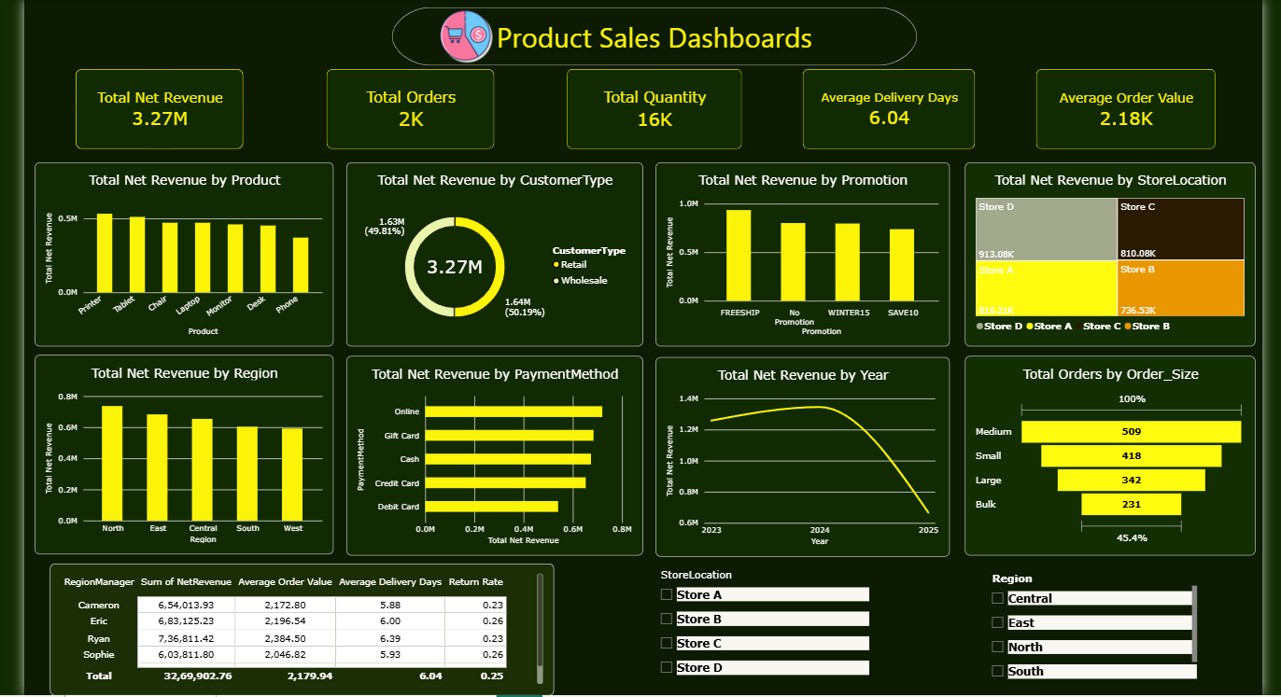
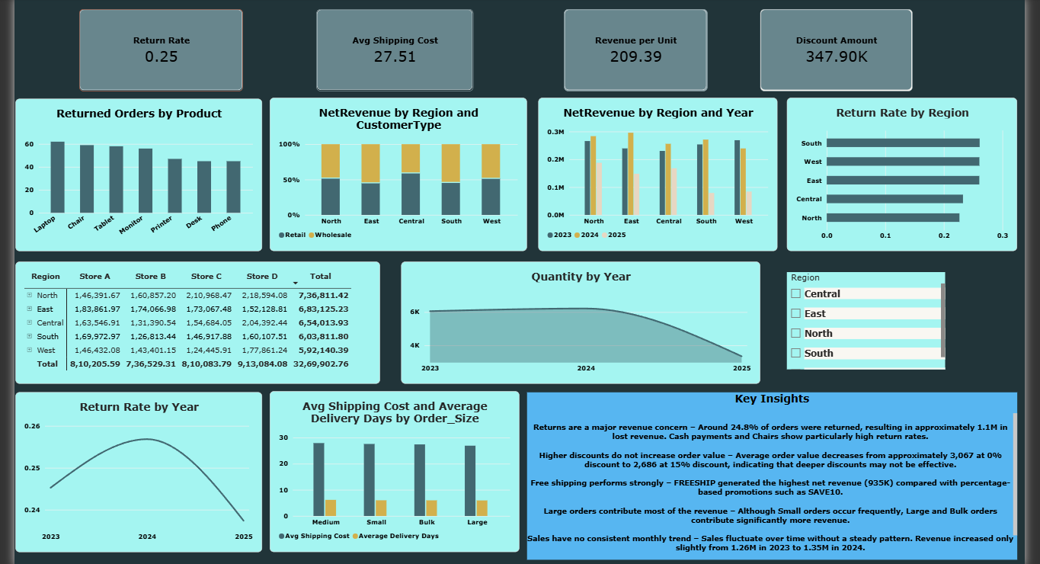

Key insights
- Returns are the biggest problem (anomaly). About 24.8% of orders were returned, which removed roughly 1.1 million of revenue. Cash payments have the highest return rate (31%) and Gift Card the lowest (20%). Chair has the highest product return rate (28%).
- Discounts do not help (correlation). Average order value falls from about 3,067 at 0% discount to about 2,686 at 15%, so discounts lower revenue per order without increasing order size.
- Free shipping works best (pattern). FREESHIP earned the most net revenue (935K), more than percentage discounts such as SAVE10 (738K).
- Revenue is concentrated in big orders (pattern). Bulk and Large orders drive most of the revenue, even though Small orders are common.
- No clear sales trend (trend). Monthly sales go up and down without a steady pattern, and 2023 (1.26M) to 2024 (1.35M) shows only slight growth.
The dashboard shows a business with balanced sales across regions, customer types and products, so no single area is failing. The real weakness is not who buys or where, but what happens after the sale: a quarter of orders are returned, and many discounts reduce order value without bringing larger orders. The strongest levers are free shipping offers, big orders, and the top region (North) and products (Printer and Tablet).

Recommendations
- Promote free shipping offers more and review SAVE10 and WINTER15 discounts.
- Investigate returns, especially for cash payments and chairs, because this is the biggest revenue loss.
- Focus marketing and stock on North, Printer and Tablet, and plan campaigns to improve South, West and Phone.
- Encourage Medium, Large and Bulk orders using bundles or minimum order offers.
- Share the practices of the best store (Store D) and the best salesperson (Bob) with weaker ones.
- Reduce the 6.04-day average delivery time where possible.

CONCLUSION
The analysis covered the full process, from cleaning 1,500 sales records to creating 14 EDA charts and a Power BI dashboard. Sales are spread evenly across regions, customer types and products, but returns and ineffective discounts reduce the revenue the business keeps. Reducing returns and using promotions more carefully, especially free shipping, are the best ways to improve sales performance.

